NEWSLETTER COPY:

Report and Recommendations of the GTMRx National Task Force: Building Vaccine Confidence in the Health Neighborhood June 2021
Ending the ravages of the COVID-19 pandemic requires widespread vaccination, yet the immunization rate is slowing across the United States. Surveys suggest that a third of U.S. adults do not want to be vaccinated. Building confidence in the vaccines to boost uptake is urgent, says a new report from the bipartisan GTMRx National Task Force focused on building vaccine confidence in the health neighborhood. The Task Force, made up of leaders in health care, public health and academia, calls on communities across the nation to create grassroots organizations called Vaccine Confidence Leagues, which can mobilize trusted messengers from those communities to address individuals’ concerns and boost vaccine confidence and uptake. Read their report here.

SOCIAL MEDIA COPY:

Ending the ravages of the COVID-19 pandemic requires widespread vaccination, yet the immunization rate is slowing across the United States. Surveys suggest that a third of U.S. adults do not want to be vaccinated. Building confidence in the vaccines to boost uptake is urgent, says a new report from the bipartisan @GTMRx Institute National Task Force focused on building vaccine confidence in the health neighborhood. Read the report here: bit.ly/VaccineRecRptPage

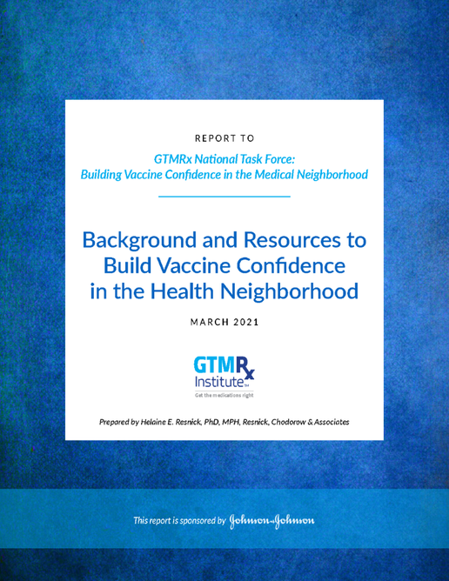
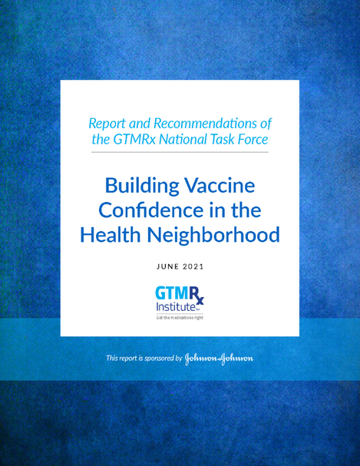
IMAGES (RIGHT CLICK TO SAVE IMAGE)

