Nicole Scovis, Pharm.D., BCPS, BCACP
Strategic Growth Director, Tabula Rasa HealthCare

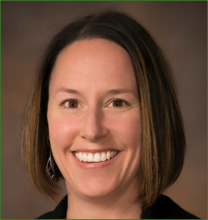
Dr. Scovis is actively engaged in the integration of clinical pharmacy services into innovative settings and programs including medication therapy management, non-profit organizations, private practice clinics and hospitals. Throughout her career, Dr. Scovis has advocated for the highest clinical practice standards through development and maintenance of medication therapy management programs, active practice in integrated primary and behavioral healthcare and work with students and residents at multiple colleges of pharmacy. Dr. Scovis has been recognized for her contributions to the profession, serving on the faculty at the University of Arizona College of Pharmacy for over 10 years and receiving both the pharmacist of the year and exemplary patient care awards from the Arizona Pharmacy Association. Currently, Dr. Scovis is the director of strategic growth for Tabula Rasa HealthCare where her focus is on development of financially sustainable clinical pharmacy models that provide optimal outcomes for patients.
Dr. Nicole Scovis graduated with her Doctor of Pharmacy from the University of Florida. She completed pharmacy residency training at the North Florida/South Georgia Veterans Healthcare System in ambulatory care and subsequently obtained board certification as both a pharmacotherapy specialist and an ambulatory care pharmacist.

