Meghan Arwood, Pharm.D., MS, BCPS
Clinical Research Scientist, Tabula Rasa HealthCare

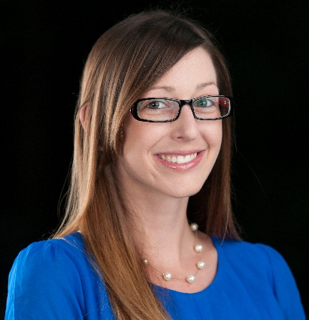
In 2017, Arwood joined the Department of Pharmacotherapy and Translational Research at the University of Florida College of Pharmacy as a clinical assistant professor. In this role, she supported the implementation of pharmacogenomics through University of Florida’s Health Precision Medicine Program. Dr. Arwood also directed a pharmacogenetics consult clinic within internal medicine for 2.5 years. For the last 3 years, she has been a board-certified pharmacotherapy specialist. Dr. Arwood recently began her role as a clinical research scientist with Tabula Rasa HealthCare at their Precision Pharmacotherapy Research and Development Institute in Orlando, Florida, where she works on various research projects and maps pharmacokinetic parameters for InterMED-Rx, a drug-drug-gene interaction software.

Meghan Arwood received her Bachelor of Science and Doctor of Pharmacy degrees from the University of Florida and completed a PGY1 pharmacy practice residency at Holmes Regional Medical Center in Melbourne, Florida. Following residency, she started a fellowship in translational pharmacogenomics at the University of Illinois at Chicago and completed it at the University of Florida. Dr. Arwood received a Master of Science degree in clinical and translational science from the University of Illinois at Chicago. Her thesis research focused on transcriptomic predictors of pulmonary hypertension development in heart failure patients.

