Julie Ceno-England, MD
Interim Chief Medical Officer, OneOme

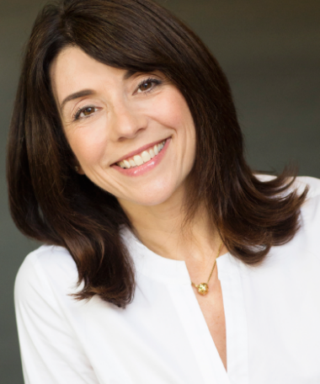
Dr. Julie England joined OneOme in September 2018. She is a board-certified physician with over 15 years of clinical experience in family medicine, which has allowed her to encounter a variety of medical issues. While performing in this setting, she became interested in precision medicine and eventually opened up a small concierge lifestyle precision medicine practice in 2017. Julie received her Bachelor of Arts in biology from the University of Michigan and her Doctor of Medicine from the American University of the Caribbean College of Medicine. She completed her residency training in family medicine at the University of Minnesota.

