Bayli Larson, Pharm.D., MS, BCPS
Executive Fellow, Association Leadership and Management, ASHP

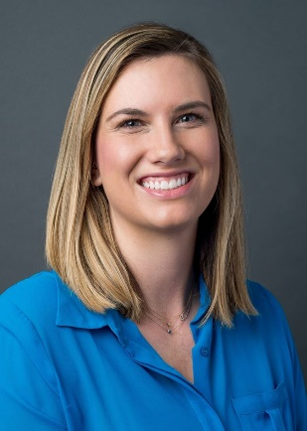
Dr. Bayli Larson is currently an executive fellow in association leadership and management at the American Society of Health-System Pharmacists. She has engaged in policy and advocacy efforts with various professional associations and national organizations including the Food and Drug Administration, Colorado Pharmacist Society and the American Society of Health-System Pharmacists.
Dr. Larson obtained a Bachelor of Science in microbiology and a Master of Science degree in toxicology from Colorado State University. In addition, Dr. Larson received her Doctor of Pharmacy from the University of Colorado Skaggs School of Pharmacy and Pharmaceutical Sciences. She then completed a PGY1 pharmacy practice residency at the UCHealth Memorial Hospital in Colorado Springs, Colorado.

