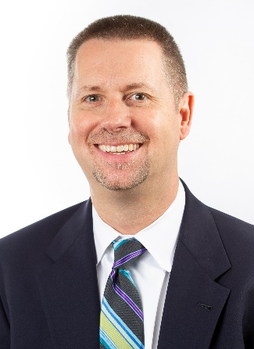
Bradley Cannon, Pharm.D.
Speaker of the House of Delegates, Board of Directors, Member, AACP

Bradley Cannon currently serves as the Speaker of the House of Delegates for the American Association of Colleges of Pharmacy (AACP), the national organization representing pharmacy education in the United States. In this role, Dr. Cannon facilitates the business of the House as it considers policies relevant to the contemporary education of the academy and strives to assist members in the creation of sound policies. Prior to this, Dr. Cannon served on the AACP Bylaws and Policy Development Committee, chairing the committee in 2017.
Dr. Cannon graduated from the University of Illinois at Chicago College of Pharmacy in 1994. After completing a pharmacy practice residency at the University of Illinois Medical Center, he joined the UIC College of Pharmacy as a clinical educator with the Department of Vascular Surgery, as well as a coordinator in the Office of Academic Programs. In 2014, he joined the faculty at Rosalind Franklin University of Medicine and Science as an assistant professor and director of experiential education.

