Heather Ourth, Pharm.D., BCPS, BCGP
National Program Manager: Clinical Pharmacy Practice Program and Outcomes Assessment, Pharmacy Benefits Management Services 10P4P, Department of Veterans Affairs
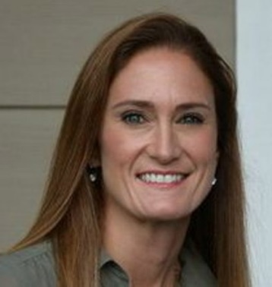
Heather Ourth, national program manager for the Clinical Pharmacy Practice Program and Outcomes Assessment for VA’s Pharmacy Benefits Management Service, is a researcher that has co-published more than 13 research articles, along with Anthony Morreale and Julie Groppi of the VA. In this role, Dr. Ourth’s work has an emphasis on program development, implementation and outcomes/impact assessments designed to evaluate the impact of clinical pharmacy services on the costs and quality of patient care. She also works to identify proven and innovative roles for pharmacists, lead clinical pharmacy health services research and quality improvement projects, author numerous publications and apply pharmacoeconomic principles to support VA initiatives in this area.

Heather received her bachelors of science in pharmacy from Ferris State University in 1995 and her doctor of pharmacy degree from the University of Florida in 2007. She is a Board-Certified Pharmacotherapy Specialist and Board-Certified Geriatric Pharmacist. Dr. Ourth was a past recipient of the VA Under Secretary for Health Pharmacy Benefits Management Innovation Award, the National Alliance of State Pharmacy Associations’ (NASPA) Excellence in Innovation Award and the Michigan Distinguished Young Pharmacist Award. Dr. Ourth is a long-standing member of many professional associations including ASHP, ACCP, APhA and the Iowa Pharmacy Association.

