Curtis Haas, Pharm.D., FCCP
Director of Pharmacy, University of Rochester Medical Center

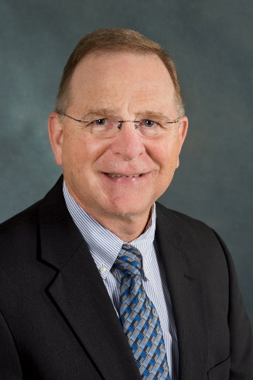
Currently, Dr. Haas is the director of pharmacy at the University of Rochester Medical Center in New York. He has also served as an associate professor at the School of Pharmacy and Pharmaceutical Sciences at the University at Buffalo in New York. Dr. Haas has 17 years of experience specializing in critical-care pharmacy practice and has organized an active research, practice and teaching program with several industry publications and national presentations in critical-care therapeutics. In addition, Dr. Haas works closely with the editorial team to raise the impact of the Pharmacy Times Health-System Edition. There, he shares insight on recent developments in the industry and assists in delivering analytical data and research to the readers. As for education, Dr. Haas received his bachelor of science in pharmacy from the Albany College of Pharmacy of Union University and his doctor of pharmacy from University at Buffalo.

