Bassel Abul-Hajj, MPH
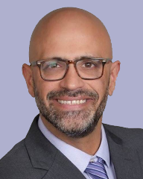
Vice President Model Development, Medecision

Bassel Abul-Hajj is currently the vice president of model development at Medecision. He has over 20 years of experience working as an analytics expert in nearly all aspects of the health care domain, including the health insurance field. Abul-Hajj has developed collaborative strategies for the application of advanced analytics throughout the health care landscape and across the globe, providing actionable insight to increase quality of care while reducing health care costs. He is passionate about resolving complex issues by designing and developing novel health care solutions. He is known for his innovation and ability to bridge the gap between business and technical interests.
Prior to his current role, Abul-Hajj worked at Well Solutions Group where he was a chief strategist for analytics. There he consulted the organization on transforming analytic products and services, helped build a strong and inventive organization and increased the bottom line for the firm and their clients. Subsequent to this, he worked as a global lead in health care analytics at the SAS Institute. Abul-Hajj has also worked at United Healthcare, Boston Scientific and Prime Therapeutics.
Abul-Hajj received his bachelors of science in molecular biology from University of Wisconsin-Madison and his masters of public health in epidemiology from Emory University.

